[Insert your business logo]

[Enter your business name]

Emergency management and recovery plan
Date: Select a date
[Use the italicised guidance throughout this template for help completing your business plan.
You may wish to remove this text before you finalise your plan.]

Download the latest version of this template from www.business.gov.au/emergencyplan

Plan management
Date last updated | Select date
Person responsible

Business details

Registration details
Business name
Australian business number (ABN)
Australian company number (ACN)
If a company.

Contact details
Name
Phone
Mobile
Email
Address

Contents
Plan management 2
Business details 2
Registration details 2
Contact details 2
The continuity plan 4
Our key products/services 4
Our main customers 9
Insurance 10
Property and infrastructure 11
Relocation options 11
Other continuity arrangements 12
Staff training 12
Information back up 13
The emergency action plan 14
Communication methods 14
Emergency contacts 14
Emergency procedures 15
Emergency action plan drill schedule 16
Emergency kit 16
Emergency team roles and responsibilities 18
The recovery plan 19
Business impact assessment 19
Recovery contacts 20
Insurance claims 21
Market assessment 21
Marketing strategy 22
Finances 23
Expected cash flow during recovery 25
Supporting document checklist 26

The continuity plan
This plan outlines how we’ll prepare our business for an emergency or disruption such as a major flood, bushfire or disease outbreak. Our continuity plan identifies essential areas of our business and how we’ll keep them running in an emergency situation.

Our key products/services
[List your 3 most important or most profitable products or services at the top of the following 3 pages. For example: shopfront coffee sales or online sales. For each one, list the essential things that help you provide that product or service in the task details row.
Describe your current arrangements and what you’d do if they failed – your back up options for an emergency.]

[Insert name of first product or service. Example: Online coffee bean sales]
Essential jobs/people
Task details | [Example: Preparing orders.]
Training/skills required | [Example: Online order system training.]
Current arrangements | [Example: Lee – trained and experienced.]
Back up options | [Example: Train 2 other staff in system.]
Essential services/supplies
Task details | [Example: Supply of coffee packaging.]
Current arrangements | [Example: ExpressO Supplies provides our branded packaging.]
Back up options | [Example: Baggit has suitable plain packaging.]
Essential equipment/systems
Task details | [Example: Online order system.]
Current arrangements | [Example: Dodgy-connect Online Sales.]
Back up options | [Example: Website notification if system is down with alternative arrangements.]
[Insert name of second product or service]
Essential jobs/people
Task details
Training/skills required
Current arrangements
Back up options
Essential services/supplies
Task details
Current arrangements
Back up options
Essential equipment/systems
Task details
Current arrangements
Back up options

[Insert name of third product or service]
Essential jobs/people
Task details
Training/skills required
Current arrangements
Back up options
Essential services/supplies
Task details
Current arrangements
Back up options
Essential equipment/systems
Task details
Current arrangements
Back up options

Our main customers
[Which important customers will need to know about an emergency situation? How will you tell them what has happened?]
The key customers we need to notify in the case of an emergency.
Customer or business name | Contact method
[Example: MiniMart store that purchases 50 bags of our coffee per month.] | [Example: We will contact MiniMart directly via phone (6543 3210) to inform them that their order may be delayed or unable to be filled.]

Insurance
[List your insurance for business risks such as building, contents, car or business interruption insurance. For each insurance policy check your product disclosure statement and list the main things your policy covers and any policy exclusions. Review the definition of terms such as floods – they vary between insurers. Check our Insurance topic for more information.]
Insurance type | [Example: Building insurance.] | [enter type] | [enter type] | [enter type]
Policy coverage | [Examples: damage from fire, floods, storms]
Policy exclusions | [Example: Damage from landslides.]
Insurance company
Contact name
Phone number
Date product disclosure statement reviewed | Select date
Payments due  Amount and frequency. | [Example: $XXX monthly.]

Property and infrastructure
[Describe how you protect your property and infrastructure from damage or theft. For example, alarms, security staff or cameras to protect against intruders, fire retardant or flood resistant building materials, fuel reduction to reduce fire risk.]
How we protect our property and infrastructure.
[Example: We regularly clear grass and leaves from around the building and clean gutters every X months.]

Relocation options
[Consider attaching a map of temporary accommodation options to your plan.]
Temporary business accommodation we can quickly access in an emergency situation.
Location type | [Examples: private home, hotel, business centre]
Address (and name if a business)
Resources and equipment available | [Examples: computers, furniture, photocopiers, phones, internet access]
Resources needed | [Examples: software, staff, business records, storage space]

Other continuity arrangements
[Check our Online topic for ideas about using digital tools to continue running your business during an emergency.]
Other ways we will keep our business going in an emergency.
[Examples: virtual office service, digital collaboration tools, e-commerce]

Staff training
Job title | Name | Expected staff turnover | Skills or strengths | Training needed
[Example: Sales manager.] |  | [Example: 12 to 18 months.] | [Example: Marketing degree. 5 years’ experience in the industry. First aid certificate 2021.] | [Example: Requires training in online order and financial systems.]

How we maintain staff skills
How we document and regularly review staff skills to make sure we maintain required skills.
[Example: We maintain a staff skills and training register and review it every X months.]

Information back up
[Find out about backing up and securing your data.]
How we back up our essential business information.
Information type | How often | Who’s responsible  Name and mobile number. | Procedure
[Examples: customer records, financial records, contact lists] | [Examples: weekly, monthly] |  | [Example: Records are backed up using cloud-based storage.]

The emergency action plan
This plan outlines what to do in an emergency and who to contact.

Communication methods
[What are your ways to communicate in an emergency situation? What method will you use to contact staff? Will one person contact all staff or will the responsibility be divided? Examples of communication methods include telephone, 2-way radio or social media.]
[Example: In an emergency situation we use our attached phone tree to contact all staff and use social media to communicate with the public.]

Emergency contacts
[List your local emergency services numbers and any additional contacts you will need to phone in an emergency, such as employees and their emergency contacts. Include the details for your state or territory emergency services.]
Organisation name | Contact | Position title | Phone number
[Example: Emergency services – triple zero] | [Examples: Fire, police, ambulance] |  | [Example: 000]
[Example: State Emergency Services (SES)]
[Example: Poison information line]

Emergency procedures
[List your emergency/evacuation procedures for events such as fires or storms. It may be useful to attach a copy of detailed emergency procedures and floor plan with the location of emergency exits, emergency kit and safety equipment clearly marked. Your emergency procedures should also include a map of evacuation locations for all emergencies.]
Emergency procedure | What to do | Evacuation location | Where to find the full procedures | Supporting documents
[Example: Fire evacuation procedure] | [Example:  1. Alarm raised and relevant emergency services authorities contacted.  2. Wait for evacuation signal.  3. Follow fire warden instructions.  4. Calmly evacuate the premises from nearest emergency exit.  5. Arrive at evacuation location.  6. Locate and account for all staff.] | [Example: Corner of Safe Street and Sound Lane, City] | [Example: The Fire and emergency procedures.doc is in the shared drive under the 'Emergency' folder. A printed copy is also in the staffroom.] | [Examples: office floor plan, map of evacuation locations]

Emergency action plan drill schedule
[Use this table to schedule regular drills of your emergency procedures.]
Procedure type | How often | Position/person responsible | Next drill date
[Examples: fire, flood or cyclone evacuation] | [Example: Monthly] | [Example: S Jones] | Select date

Emergency kit

Location
[Where is your emergency kit located/stored? Make sure it is clearly visible and labelled. Make sure your staff know where it is.]
[Example: We store our emergency kit in the kitchen.]

Emergency kit contents
[List the contents of your emergency kit and the date each item was last checked/reviewed. Add extra rows if you need to.]
Object | Checked/reviewed date | Person responsible
Emergency management and recovery plan | Select date
Emergency and recovery contacts | Select date
Insurance documents | Select date
Financial documents | Select date
Torch | Select date
First-aid kit | Select date
Portable radio | Select date
Plastic bags | Select date
Spare batteries | Select date
Adhesive tape | Select date
Pen/pencil and notepad | Select date
List of employees and contact details | Select date
Bottled water | Select date
Non-perishable food | Select date
Other | Select date

Emergency team roles and responsibilities
[Important responsibilities that need to be covered.]
Role | Details of responsibilities | Person responsible | Email | Phone numbers
[Example: First Aid Officer.] | [Example:  Administer first aid support in an emergency.  Contact ambulance services when necessary.  Attend regular first aid training courses.]
[Example: Chief Fire Warden.] | [Example:  Communicate procedures to all staff.  Supervise and action emergency evacuation procedures.  Attend relevant training courses.  Conduct regular drills.  Update procedures regularly.]
[Example: Fire Warden.] | [Example:  Attend relevant training courses.  Help evacuate staff according to evacuation procedures.  Assist with regular drills.  Assume Chief Fire Warden duties when required.]

The recovery plan
We complete this plan after an emergency happens to help recover our business.
[Find services and tools to help your business recover.]

Business impact assessment
[Based on your assessment of the damage to your business, complete the table below.]
Damage | Impact to business | Severity | Action | Recovery steps | Resources needed | Actioned by | Estimated completion
[Examples: broken packaging equipment] | [Examples: orders unable to be completed, repackaging cannot be completed on site] | Select severity | Select action | [Examples: lodge insurance claim, get quotes to repair damaged equipment] | [Examples: temporary packaging provider] |  | Select date
 |  | Select severity | Select action |  |  |  | Select date
 |  | Select severity | Select action |  |  |  | Select date

Recovery contacts
[Include all of the organisations/people that will be essential to the recovery of your business. For example: insurance providers, service providers, employees, suppliers, business advisers or lawyers.]
The key people who will help us recover.
Contact type | Organisation name | Contact | Title | Phone number
[Examples: insurance, service providers, employees, customers, suppliers, advisers, accountants] | [Example: XYZ Insurance] | [Example: G Jones] | [Example: Claims adviser]

Insurance claims
[What insurance policies have you claimed for? Use the table below to record any discussions you have with insurers about your claims.]
Insurance company | Contact details | Date of contact | Details of conversation/claim | Follow up actions
[Example: XYZ Insurance] | [Example: D Higgins,  Phone number] | Select date | [Example: The assessor will visit on Tuesday 14 May. Estimated claim amount is $XXX] | [Examples: estimating the damage, locating and listing serial numbers for stolen equipment, providing photos, do not clean up the property until inspected]

Market assessment
[Based on your assessment of the damage to your business, surrounding area and customer base, list any areas of your market that have changed. Alternatively, attach a complete market assessment to the back of this plan. Check our marketing plan template for further guidance.]
Market changes | Impact to business | Business options
[Example: Due to road damage, customers are not purchasing our product directly from our shopfront.] | [Example: We will experience a drop in shopfront sales and may have to reduce staff hours.] | [Example: We can increase online trade from our warehouse.]

Marketing strategy
[Detail your marketing strategy after the emergency. If your business is reopening its doors, how will you get the message out? What channels will you use to target customers? How does this strategy differ in light of any changes in the market?]
Activity | Channel(s) | Message
[Example: Social media campaign] | [Examples: Instagram, Facebook, Twitter, Snapchat] | [Example: We’re back! We are reopening our doors on 24 May. To celebrate, we’re giving the first 200 customers to visit us a free coffee. We can’t wait to see you.]

Finances

Current creditors
[List all current debts or loans you are responsible for paying during the recovery period. Detail any changes or special arrangements you’ve made.]
Creditor name | Contact details | Special arrangement details | Period of special arrangement | Amount ($)
[Example: Banking Corp.] | [Example: J Harmer, Business Loan Adviser,  phone number, email] | [Example: Loan temporarily changed to interest only arrangement for the period of recovery.] | [Example: 6 months, ending on Day/Month/Year] | $

Current debtors
[List all current payments that you are owed, the relevant contact, their agreed payment amount and date.]
Name | Contact details | Details | Agreed payment date | Amount ($)
[Example: MiniMart] | [Example: P Fred,  phone number, email] | [Example: We are owed for 50 bags of coffee.] | Select date | $

Government funding
[List government funding you’ve applied for and the amount. You can find government funding by searching in our Grants & Programs tool.]
Program name | Contact details | Funding details | Date of application | Amount ($)
[Example: Flood relief package.] | [Example: R Smith, Rural Assistance Authority,  phone number, email] | [Example: Our business is eligible for funding that goes towards repairing and restoring damaged equipment.] | Select date | $

Expected cash flow during recovery
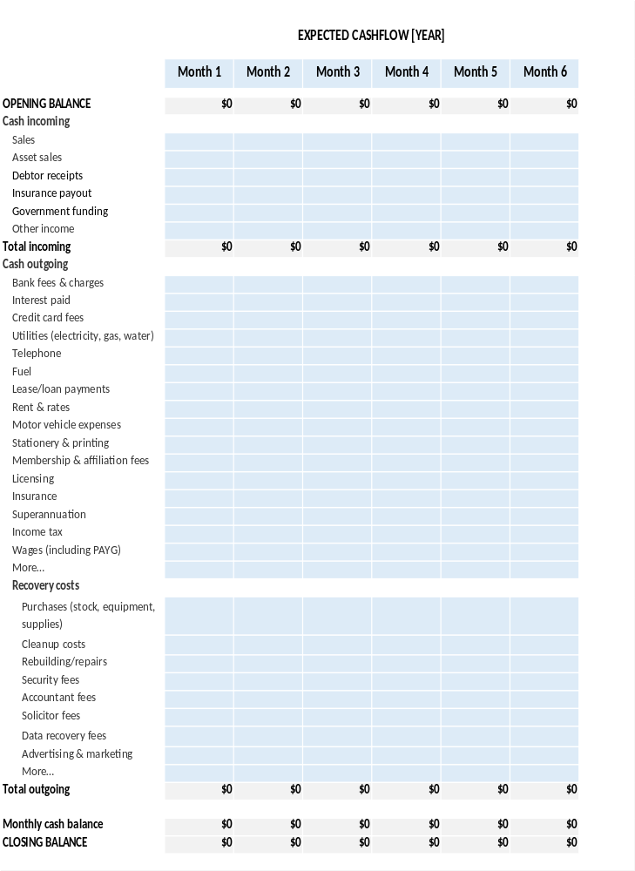

Supporting document checklist
Attached documents (where relevant):
☐ Emergency procedures
☐ Financial documents
☐ Floor plan
☐ Impact assessment
☐ Insurance information
☐ Market assessment
☐ Staff contact list

